Single Page Application Architecture in AngularJS

How a single page application architecture look like?

The **architecture of the Single Page Application** looks pretty simple, as we are going to use [AngularJS](https://techfunda.com/Howto/angularjs) and[ASP.NET Web API](https://techfunda.com/Howto/asp-net-mvc/web-api) in this demonstrations so here is how the architecture looks like

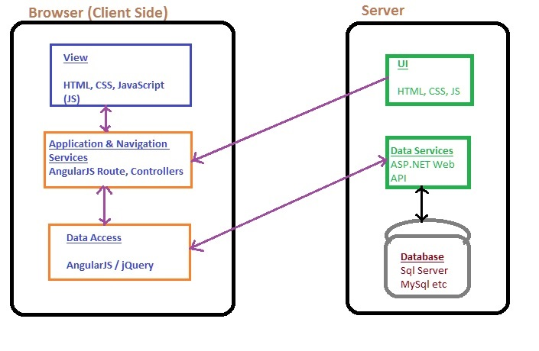

Single Page Application Architecture

Server side

The server side of the application mainly provides the data storage and templates that will be shown to the end user. It contains following

1. **Database** - depends on what we have or want to use, we can use SQL Server, MySql or any other. In this case we will be using SQL Server database
2. **Data Services** - Any service that exposes the data via URL over HTTP protocol. We are using ASP.NET Web API.
3. **UI** - templates that we want to use to show data or get input from user

Client side

The client side of the application contains data manipulations, navigation services and any other stuffs we want to do to show the view to the user.

It contains following

1. **Data Access** - In our case we will be using[AngularJS $http services](https://techfunda.com/Howto/angularjs/http-service) to send and receive data.
2. **Application & Navigation services** - This mainly contains  
   * how the navigations (which view it goes to) would happen when user clicks on the menu link
   * what events executes when user clicks on button or links
   * how the application would call the data services etc.
   * whether application need use offline storage etc.
3. **View** - It conains the Views and placeholder where Views (User interfaces) will be loaded based on user navigations.